Admin Dashboard:

This is the dashboard to be implemented for the admins of WinPoint.

It will consist of following parts:

1. Login Page

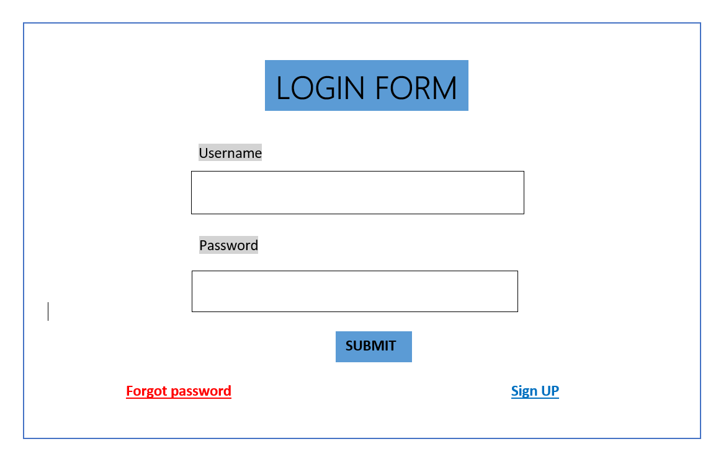

Login page is used for login by the admin (common for both admin and students).

It consists of following fields:

* Username:

The username is to be used for login in the website and for test administration.

* Password:

It will be unique to each user (admin and students both) for login into the website. Changeable under the settings tab in the dashboard after login.

* Forget Password:

The forget password will allow the user to change the forgotten password through reset link sent by email.

When ’Submit’ button is pressed, the backend will verify its uniqueness with the database and if the username and password are correct, the user will be logged in.

Otherwise, the error message will appear.

1. After successful login, main dashboard for admin will open on the screen.

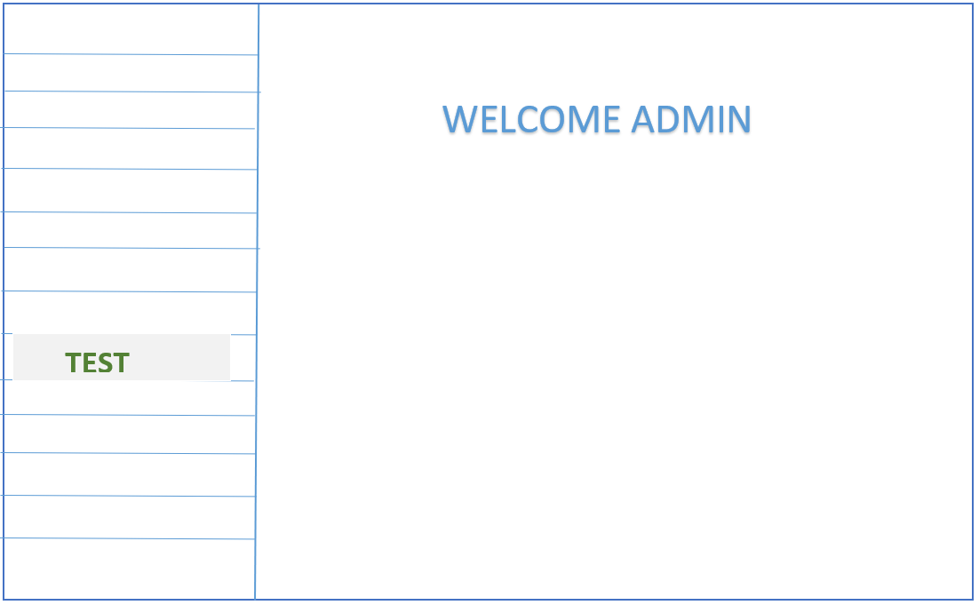

Admin Dashboard:

It contains the tabs for general administration of WinPoint as well as test management.

Contents:

1. Reports (Overall reports as per the student, batch or subject)
2. Tests (Overview of the tests.)
3. New Registration (To review the new registrations on the site for new courses)
4. Enquiries (Will show the new enquiries on the site, through mails)
5. Test (Will let the admin design the test, add the questions, and make the test live for attending)

(Tabs A through D are not shown in the tentative diagram above).

After clicking on the test tab, Test Dashboard for admin will open.

1. Test Dashboard for Admin

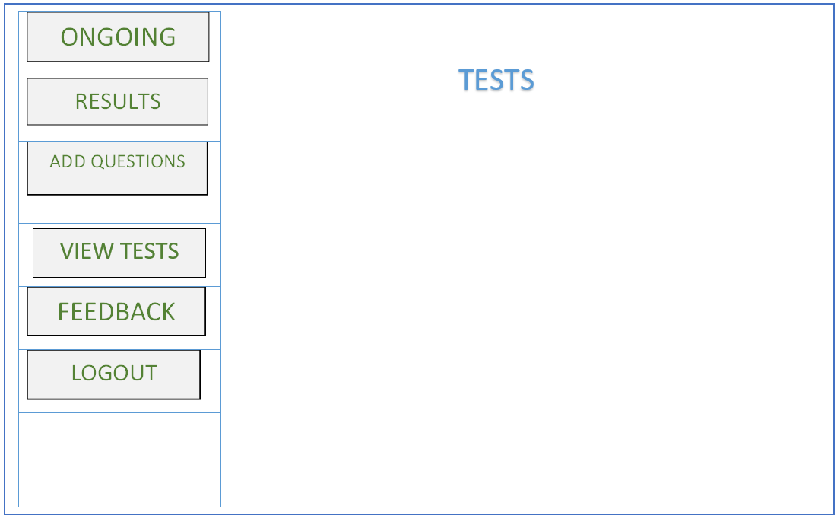

The dashboard will be as follows:

The dashboard will allow the administrator to manage the ongoing tests, design new tests, see the results of the latest tests. Also, it will allow the admin to add the questions in the database and logout option will be there.

The contents of the Test Dashboard will be as follows:

1. Ongoing:

Ongoing Tab will show a table which will contain columns like Student ID, Student Name, Test Subjects, Test name, Time left, Pause, Reset, Submit. Here Pause, Reset and Submit are buttons which provide some functionality.

* Pause button will pause the test of the particular student.
* Reset button will start a completely new test for the student, including shuffling the questions.
* Submit button will submit the test of the particular student.

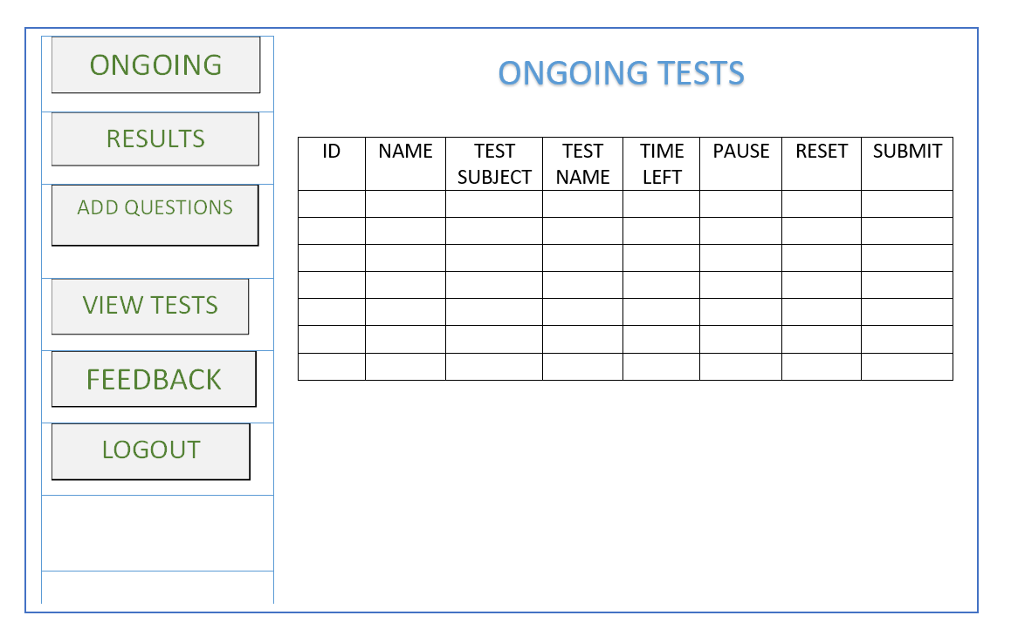

1. Results:

On the Result Page we will provide some filter conditions like filter by student name, student id, Subject wise or any other. Then it will display the requested records.

Also, it will allow the admin to view and analyse the Pie charts.

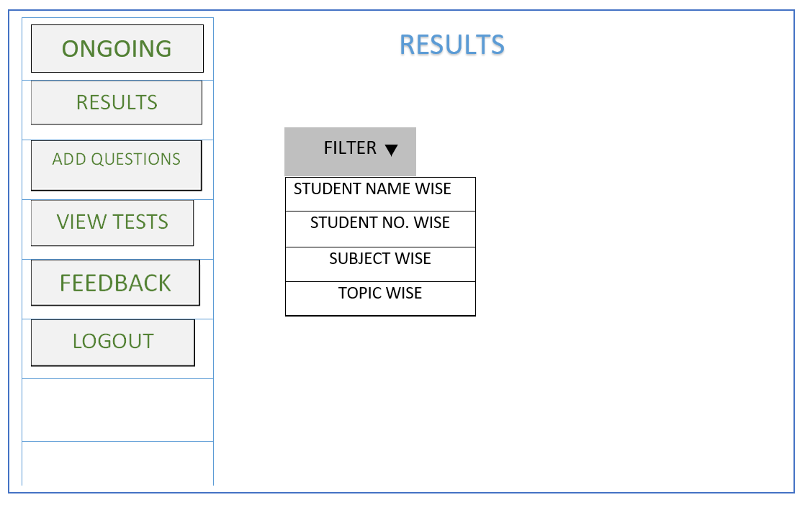

1. Add Questions:

Questions will be added in the database of the corresponding subject, along with topics, inclusive of all with difficulty level categorized as Easy, Medium and Hard Questions.

The topic of the question will be decided as per the subject selected in the dashboard.

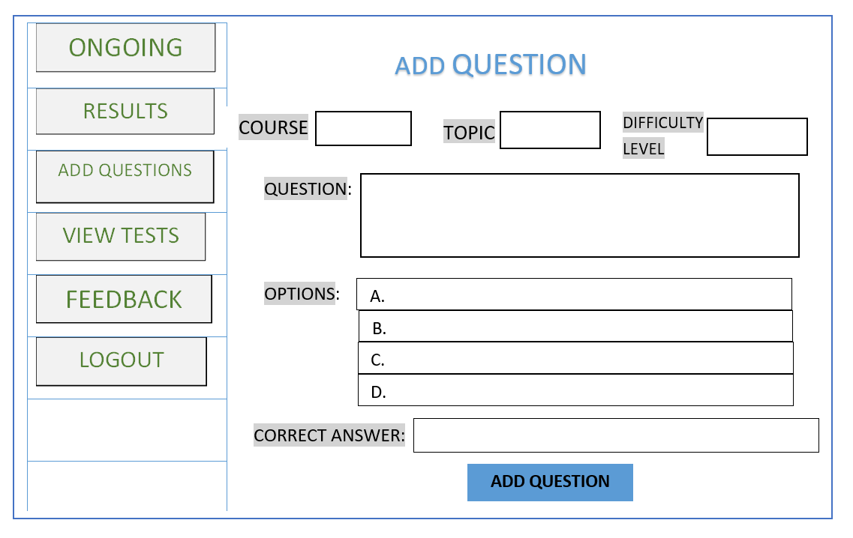

1. View Tests:

A specific format will be decided for providing questions directly to the students. This Questions format will be decided by adding number of Easy, Hard and Medium Questions.

The format for Behavioural skills and CRT is same.

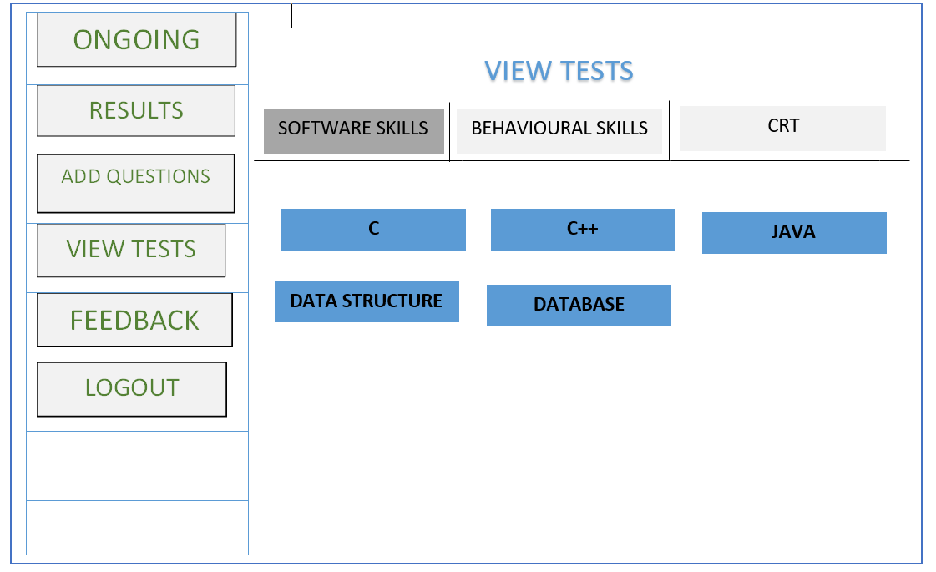

1. Feedback tab:

After completing test each and every student will have to submit a feedback form in which the student experience of that test will be counted. The Admin will be able to see the feedbacks given by each student in the form of a table. This table would consist student name, student ID, date of test, test subject, test name and a message.

Also, the sentiment analysis of the test will be done as per the responses by the students.

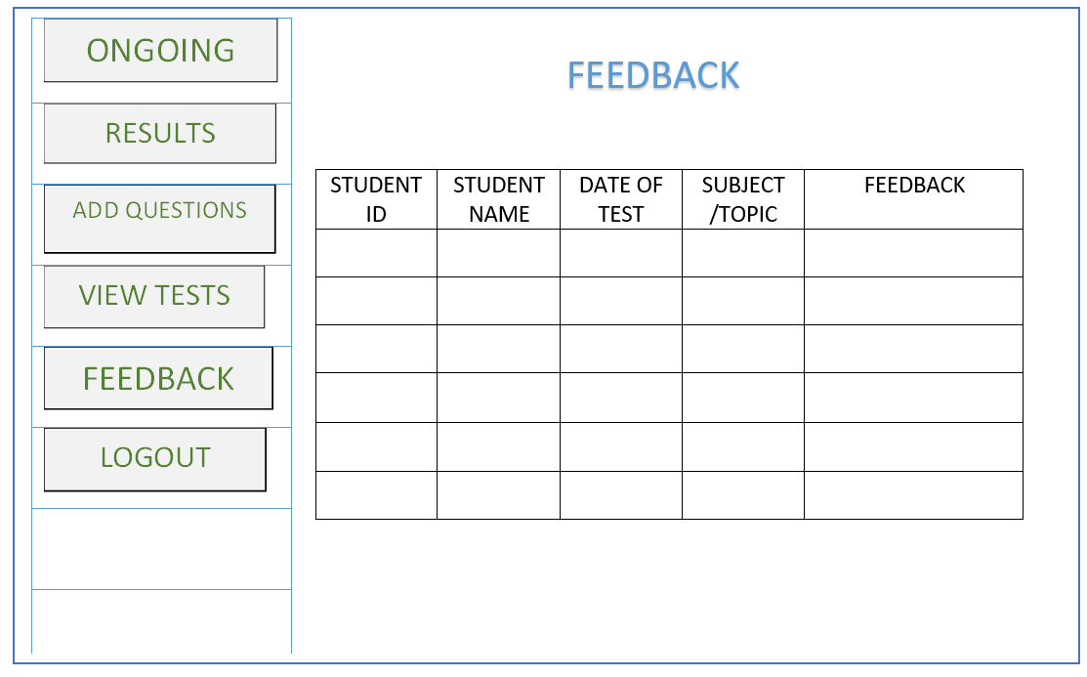

1. Logout:

By clicking on this button Admin will be able to logout and go back to the website.